Measuring Relevance Alignment between Physicians and LLMs in Medical Question Answering

Yuexing Hao, Ph.D.1,2 *, Kumail Alhamoud, M.S.1, Hyewon Jeong, M.D., M.S.1, Haoran Zhang, M.S.1, Grace Yan, B.S.1, Isha Puri, B.S.1, Philip Torr, Ph.D.3, Mike Schaekermann, Ph.D.6, Saleh Kalantari, Ph.D.2, Ariel D. Stern, Ph.D.4,5, and Marzyeh Ghassemi, Ph.D.1

1Massachusetts Institute of Technology, Cambridge, MA, 02139, USA
2Cornell University, Ithaca, NY, 14850, USA
3University of Oxford, Oxford, UK
4Hasso Plattner Institute, Potsdam, Germany 5University of Potsdam, Potsdam, Germany 6Independent Researcher
*Corresponding Author: yuexing@mit.edu

ABSTRACT

Large Language Models (LLMs) have demonstrated strong performance on medical question answering (QA) benchmarks, including standardized medical exams. Correct answers alone, however, do not guarantee correct reasoning, as a model can reach the right conclusion while attending to input that a clinician would consider unimportant. In this study we evaluated how physician trainees and LLMs reported sentence-level relevance when answering clinical QA items. We obtained annotations on 933 QA pairs from 53 physician trainees, with a subset independently reviewed by 7 board-certified physicians. These annotations labeled each sentence of the case description as high-relevance, low-relevance, or irrelevant. We then compared these human annotations against LLM-derived relevance labels, and measured the effect of restricting the LLM input to the sentences each labeler considered relevant. The average sentence level concordance between LLMs and the physician trainees’ majority vote ranged from 44.9% to 65.9%, while the concordance between physician trainees and the board certified physicians was 72.4%, indicating a modest but consistent gap. Removing sentences that physician trainees judged low relevance or irrelevant increased the accuracy of most LLMs on the four source datasets, and similar but more modest gains were observed when each LLM filtered its own input or the input of another model. These results suggest that current LLMs do not consistently prioritize the same case information as physician trainees, and that relevance-aware filtering can potentially be a useful aspect of model reasoning. The findings are based on multiple choice exam questions and should be interpreted as an evaluation step, rather than direct evidence of readiness for clinical deployment.

Main
Large language models (LLMs) have shown strong performance on medical diagnostic tasks¹, with systems such as GPT-4² and MedPaLM³ outperforming human averages on standardized medical examinations^{4–8}. Multiple LLM companies including OpenAI and Anthropic have launched the specific HIPAA-compliant LLMs targeting the healthcare market. However, the high performance of these LLMs on exam-style datasets may overstate their generalizability^{9–11}, due to multiple-choice exam tasks not reflecting the complexity of real-world use cases, among other issues¹². In human-facing settings, it is crucial to understand how models filter and prioritize relevant information¹³.
Estimation of contextual relevance is a critical aspect in many applications^{14–16}. Techniques such as semantic entropy¹⁷, influence functions¹⁸, context attribution^{19,20}, and evidence inference²¹ have been employed to assess which elements within a context hold the most importance. Despite these efforts, existing relevance estimations are often imprecise and noisy, with models sometimes producing misleading or overly confident assessments that deviate from human judgment²². Even when estimations appear less noisy, model-generated relevance labels may not concord with those of human experts. This gap is particularly concerning in human-facing domains where alignment with expert judgment is necessary^{23,24}.
Models may depend on input features that a clinician would not treat as informative²⁵. Prior work has shown that restricting inputs to relevant content can reduce distraction, streamline evidence integration, and lower memory requirements^{26–29}. Small, clinically unimportant perturbations of medical questions have also been shown to produce statistically significant shifts in model treatment recommendations³⁰. To date, however, little work has examined whether models and physicians agree on which case information is worth attending to, or whether concentrating models on such content measurably improves downstream answers.
Characterizing the extent to which LLMs attend to the same input sentences that clinicians treat as informative is a useful step toward

1

understanding how these models derive their answers^{31,32}. Such comparisons can complement accuracy based evaluation by flagging cases where a correct answer is accompanied by reliance on sentences that clinicians would not regard as decisive^{33,34}. Alignment between model attributed and clinician identified evidence has also been proposed as one of several factors relevant to clinician trust in diagnostic AI tools^{35,36}. Restricting LLMs to sentences that clinicians judge highly relevant provides an auditing lens to evaluate the extent to which model predictions depend on content that humans consider peripheral^{37–39}. Such dependencies do not always reduce benchmark accuracy, but they can complicate the interpretation of benchmark performance.
A related concern is that LLMs may be trained on data that overlap with public medical benchmarks. Relevance aware filtering does not by itself distinguish memorization from genuine reasoning, but it offers one additional axis along which such effects can be examined. In our setting the four source datasets spanned release dates from 2020 to 2025, so the potential for training set contamination varied across subsets; we treated this as a confound rather than as a controlled variable.
To study how physician trainees and LLMs rate the relevance of contextual input in patient cases, we curated a novel dataset called MedPAIR (Medical Physician trainee and AI Relevance), which pairs sentence-level relevance annotations from physician trainees with LLM-derived relevance labels on the same QA items. We then used this dataset to run an empirical study of relevance misalignment. Three research questions organized the study:
RQ1: To what extent do physician trainees and current LLMs agree on which sentences of a clinical vignette matter for answering its question?
RQ2: Does restricting an LLM’s input to sentences that physician trainees labeled as highly relevant change downstream answer accuracy, and how should such changes be interpreted given potential confounds?
RQ3: Can an LLM’s own sentence-level relevance scores drive comparable filtering effects using a two-stage process, so that the approach does not depend on human annotation?
Medical QA datasets are a primary method of evaluating LLM performance in clinical tasks^{40–43}, yet existing resources primarily score final answers and do not track which parts of the case the model or the human relied on for obtaining that answer^{44–46}. Recent work on explanation-generation and qualitative reasoning analyses has instead focused on the reasoning produced after the input context has already been interpreted⁴⁷.
We collected sentence-level relevance labels on 933 samples drawn from four source datasets: Massive Multitask Language Understanding (MMLU)-precision medicine (192 QAs)⁴⁸, Medbullets (160 QAs), JAMA Clinical Challenge Dataset (295 QAs)⁴⁹, and MedXpertQA (286 QAs)⁵⁰. These labels were produced by 53 physician trainees, and an additional 7 physician experts were asked to spot-check the labels to confirm their reliability. For the LLM-generated relevancy labels, two distinct approaches were used. First, we prompted all of the studied LLMs (GPT-4o⁵¹, GPT-5⁵², MedGemma-27B⁵³, Qwen2.5-14B-Instruct, Qwen2.5-72B-Instruct⁵⁴, and Llama-3.1 70B-Instruct⁵⁵) to self-report sentence-level input relevance^{56,57}. Second, we used ContextCite⁵⁸ to retrieve sentence-level relevancy from the four open-source LLMs tested.
To address the research questions we first measured sentence-level rating concordance (see the Methods section for more details). The physician experts were found to agree with the physician trainees’ majority vote at 72.4%, while LLM concordance with the physician trainees’ majority vote ranged from 44.9% to 65.9%. We then examined how restricting the input to the sentences marked as highly relevant affected downstream LLM performance. The results indicated that most of the LLMs gained accuracy after this filtering, both when the filter was derived from physician trainee labels and when it was derived from an LLM. Finally, we quantified a Spurious Rate per model, defined as the fraction of originally correct answers that become incorrect once sentences identified by physician trainees as low-relevance or irrelevant were removed. This rate ranged from 5.8% to 24.8% in our sample; it is best interpreted as a proxy for the LLMs’ reliance on content that physician trainees did not consider decisive, rather than as a direct measure of spurious reasoning. Overall, the study contributes an empirical characterization of how current LLMs and physician trainees diverge on sentence level relevance in clinical QA, alongside the release of MedPAIR as a paired-annotation dataset that enables this analysis as well as potential related work in future studies.

Results

The MedPAIR Dataset and Study Design
    - Medical QA Dataset Construction
To examine the alignment between physician trainees’ and LLMs’ assessments of relevance, we concentrated on existing QA pairs grounded in specific patient case scenarios, rather than general evidence-based questions. We drew on four source datasets released in different years: Massive Multitask Language Understanding (MMLU)-precision medicine (released September 2020)⁴⁸, Medbullets (released March 2021), JAMA Clinical Challenge (items collected from July 2013 to October 2023)⁴⁹, and MedXpertQA (released January 2025)⁵⁰. The Medbullets and JAMA papers were preprinted in April 2025, and JAMA items require paywall access. The four source datasets had different characteristics; for example, JAMA Clinical Challenge items are usually lengthier and include more extensive details compared to the other three datasets. More extensive characteristics for each dataset are presented in the Supplementary Information. Each source provided multi-sentence patient case descriptions paired with questions (4-option or 10-option multiple-choice) and the associated answers, offering a rich context for relevance annotation. Such patient vignettes are broadly recognized as important training and evaluation documents in the medical and social sciences, and physician responses to clinical vignettes have been shown to predict realized billing behavior in the U.S. Medicare system⁵⁹. We obtained approval from the MIT Committee on the Use of Humans as Experimental Subjects (IRB: 2504001610) and preregistered our dataset collection protocol on the Open Science Framework (OSF)⁶⁰. No personally identifiable patient information was involved in this study.

Open-Source LLMs

Dataset | Data Source | Total QA | Number of Answer Options | Average  Sentence Rating | Sentences Labeled  as  Low-Relevance or  Irrelevant (%)

MMLU  (Precision Medicine) | Medical Textbooks | 192 | 4 | 15.9 (7.0) | 39.5%
JAMA  Clinical Challenge | Journal Articles | 295 | 4 | 26.8 (8.5) | 35.0%
MedBullets | USMLE | 160 | 4 | 21.0 (4.6) | 40.5%
MedXpertQA | Licensing Exam | 286 | 10 | 14.9 (5.6) | 32.8%
Overall |  | 933 | 4/10 | 21.3 (8.8) | 36.1%

Table 1. Comparative Analysis of Physician-Trainee Annotations. Values in parentheses represent standard deviations.
Physician

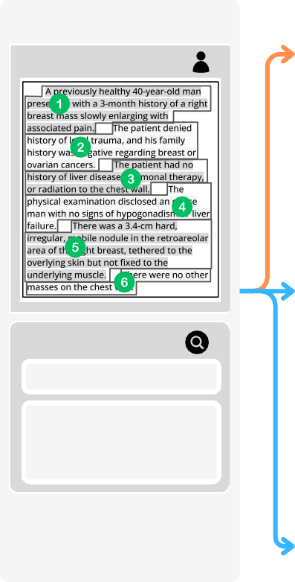
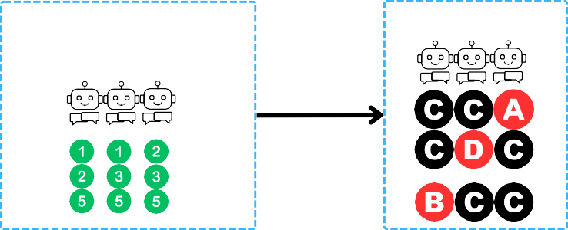
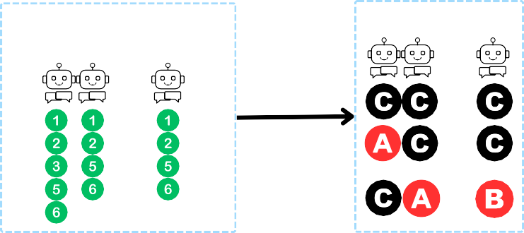
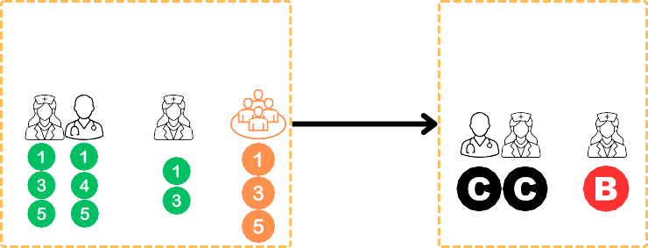





Figure 1. Study Design.
Round 1: Annotations
Round 2: Re-Gradings
Original
Context
Patient Profile
Majority-Vote Labels
52 Trainees + 7 Physicians
......
Low/Irr Sentence Filtering
8 Trainees

......
ContextCite Labels
3 Models
Query
What is the diagnosis?
......
......
- Gynecomastia
- Lipoma
- Carcinoma
- Epidermal inclusion cyst

Correct Answer:
C. Carcinoma
Self-Report Labels
6 Models
......
......
......
......
Closed-Source LLMs

Across the four datasets, there were 4,052 QA pairs in total. We removed 2,052 pairs in which the patient profile contained fewer than three sentences. We also excluded 629 pairs that had one or no correct answers, as well as 448 pairs that required information from modalities other than text (e.g., images). This left us with a final set of 933 QA pairs that were used in MedPAIR. An online commercial labeling platform was used to recruit 52 physician trainees. These participants produced a total of 6,224 sentence labels on the 2,000 QA pairs. We removed all questions that no PT could answer correctly (448 pairs), leaving us with 933 QA pairs.

    - Expert Review and Content Analysis of Physician Trainee Labels
Physician-trainee participants were used in the study due to the logistical difficulties and expense of having board-certified physicians annotate the full dataset. To verify the reliability of the trainee annotations, we used an expert physician review to spot-check a randomly selected subset of the trainee labels. To compare the two groups, we aggregated the trainee labels on each sentence into a single majority vote and compared it to the label assigned by a board-certified physician. The average sentence-level matching rate between the physician trainee majority vote and the reviewing physicians on the items tested was 72.0% (median 73.7%, SD 17.7%, 95% CI [0.710, 0.730]). A cumulative distribution of these matching rates is presented in the Appendix. We interpret this value as a measure of trainee physician agreement rather than of trainee accuracy, since the physicians themselves were a small cohort and inter-physician disagreement was not separately evaluated.
We referred to QA items for which the expert matching rate fell below 20% as ambiguous cases and retained them in the dataset so that this subgroup could be analyzed separately. Where the downstream analyses in this paper treat the physician trainee majority vote as a reference, this choice is a pragmatic one driven by scale, and the resulting concordance and filtering results should be interpreted against the 72.0% overall expert-matching average.
As a further step, a single board-certified physician was asked to conduct a qualitative comparison of labels that trainees had marked as high- and low-relevance across 30 randomly selected QA pairs. This evaluation indicated that sentences regarded as highly relevant contained more information about anatomical structures and comparative descriptions (e.g., progressive, increased), whereas low-relevance text included more historical information (e.g., medication, allergy, travel, social) and negative findings (e.g., uncomplicated, noncontributory
). This physician further grouped the low-relevance and irrelevant sentences into four thematic categories, including (1) Redundant clinical details, (2) Negative result that is not essential for the current chief complaint, (3) Low or irrelevant temporal information, and (4) History that provides little relevant clinical information. Further details of this sample case study are presented in the Supplementary Information.
The trainee relevance labels on all 933 QAs were also compared numerically in terms of words per sentence and perplexity. The highly relevant sentences were found to be consistently longer as well as more uniform in structure, with lower perplexity values and thus greater linguistic predictability. In contrast, irrelevant or low-relevance sentences were shorter on average and had less uniform structures. Further details of this analysis are presented in the Supplementary Material.

Humans and LLMs Often Disagree on Information Relevance (RQ1)
To compare the continuous ContextCite scores produced for the open source LLMs with the ternary labels assigned by the physician trainees, we mapped the numerical scores into the ternary scheme. For each QA pair, we let k equal the number of sentences marked as highly relevant by the physician trainees’ majority vote. We then ordered all sentences by their ContextCite scores and assigned the top k sentences to the high relevance category. A similar process was followed to categorize the remaining ContextCite scores as low relevance or irrelevant using the corresponding trainee counts. This procedure aligns the LLM and human label distributions per item, which makes concordance directly interpretable in terms of which sentences each source considers most important. Since the total number of sentences placed in each category was held fixed across labelers for a given QA, the resulting concordance rates reflect the ordering produced by each method rather than differences in how many sentences each method would otherwise label as relevant. We therefore treated concordance in this paper as a measure of ranking agreement. The sensitivity of concordance to alternative thresholding choices is discussed in the Supplementary Information. With the ContextCite scores mapped onto the same ternary scheme, we were able to evaluate their correspondence with the physician trainee annotations.
For the self-reported LLM relevance scores, we ....

The best performing model, Llama-70B, reached a mean agreement of 65.9% with the physician trainees, which is below the 72.0% rate of expert physician agreement but not dramatically so. Overall, roughly one-third of sentences that physician trainees considered highly relevant were not regarded as highly relevant by at least one of the
studied LLMs (

Figure 2).

A common pattern noted in these disagreements was over-attention to superficial cues in the LLM ratings. For example, a model might latch onto a laboratory value that was extreme and assume it to be important, even if it was not relevant to the question at hand. Conversely, models sometimes missed subtle but crucial cues that humans tagged as relevant. These findings could be partially due to LLMs attributing incorrect answers on misinterpreted or irrelevant context, indicating flawed input context relevance estimates. ContextCite highlights cases where a model justifies its answer by citing a sentence it wrongly deems supportive, a phenomenon that researchers call contributive attribution.

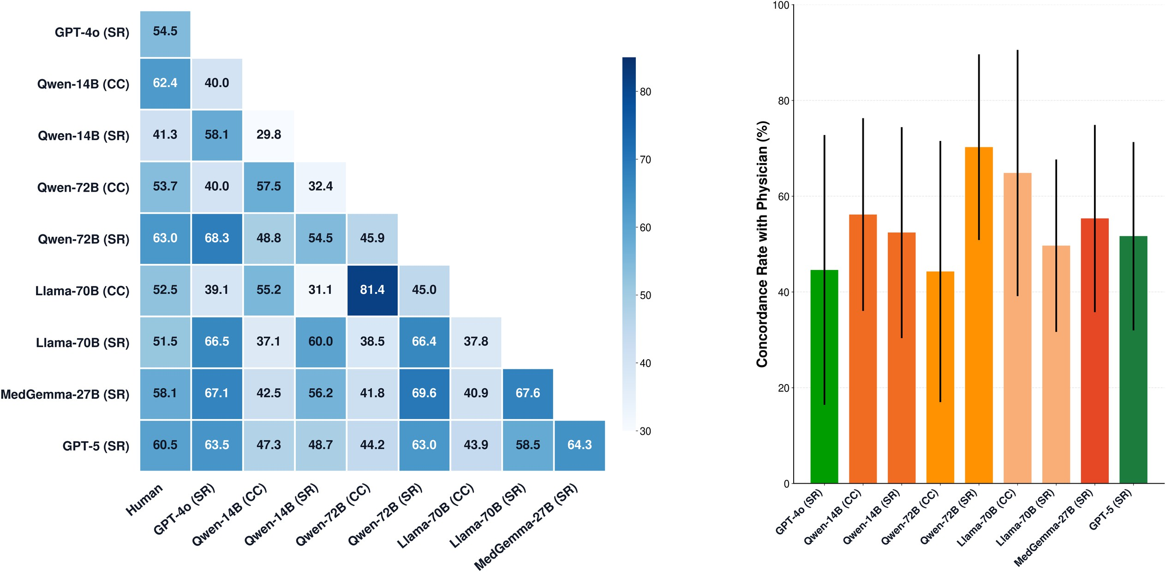
A Heatmap for LLMs Vs LLMs on Concordance Rate (%) B Average Sentence-Level
Label Concordance (%)


C Sample QA (MedXpertQA)
# LLM 1 LLM 2 Physician

1

2

3

4

5

6

7
Patient Profile
- A 20-year-old woman comes to the primary care clinic with complaints of a progressively worsening sore throat, dry cough, and ear pain.
- She reports feeling mildly unwell for two weeks prior, with symptoms
including fever, fatigue, muscle aches, and headache.
- Her medical history is unremarkable, and her only daily medication is a
combined oral contraceptive pill.
- She works as a waitress at a local diner and mentions exposure to sick patrons.
- On examination, her temperature is 101.5℉, blood pressure is 118/76
mmHg, pulse is 78/min, and respiratory rate is 14/min.
- Chest auscultation is unremarkable, but a chest X-ray reveals bilateral
multifocal opacities in the lungs.
- Sputum culture and Gram stain are negative.
Which of the following components is essential for culturing the most likely causative organism?
- Iron
- Urea
- Magnesium
- Cysteine
- Glucose
- Nicotinamide
- Cholesterol (Correct Answer)
- Hemin
- Sulfate
- Pyridoxine

High | Low | High
Low | Low | High
High | Irrelevant | Low
Irrelevant | Low | High
Low | Low | Low
High | High | High
Irrelevant | High | High
Figure 2. Average Sentence-Level Label Concordance. Panel A shows the sentence-level concordance between physician trainees and LLMs, as well as between the various LLMs studied. This concordance was highly variable across different LLMs. “CC” denotes that the comparison used ContextCite score and “SR” denotes that it used self-reported labels. Panel B shows a sample item from MedXpertQA. Panel C shows ....

Total

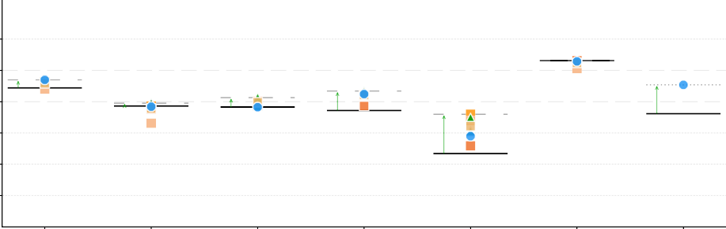
100
+0.0%
+7.5%
+35.2%
+3.2%
+10.6%
+22.9%
+94.0%
80
Accuracy (%)
60
40
20
0
GPT4o
Qwen-14B
Qwen 72B
Llama-70B
GPT 5

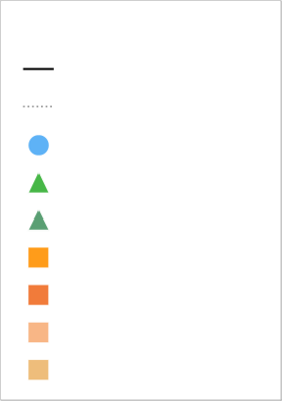
MMLU JAMA

Labeler Configuration Original Accuracy Best Performance Trainee Removed GPT-4o Removed GPT5 Removed Qwen-72B Removed
Qwen-14B Removed Llama-70b Removed MedGemma-27B Removed
MedGemma-27B
Physician + Trainee

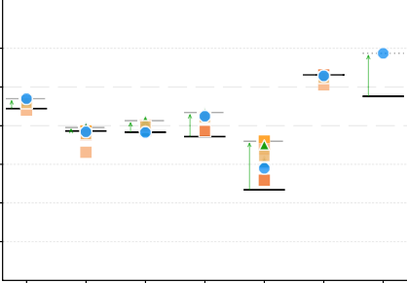
Dataset Release Date
100
80 +7.5%
Accuracy (%)
+3.2%
60

+10.6% +22.9%

+94.0%

+0.0%

+29.5%

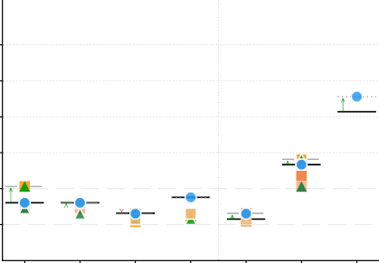
100
Dataset Release Date
+13.4%
+9.1%
+75.0%
+0.0%
+0.0%
-3.0%
+106.3%
05/24 09/24 09/24 12/23 05/25 08/25
80
60

40 40
20 20

0
05/24
GPT4o
Qwen-14B

09/24
Qwen 72B

09/24
Llama-70B
MedGemma-27B

12/23

05/25
GPT 5
0
08/25
GPT4o
Qwen-14B
Qwen 72B
Llama-70B
MedGemma-27B
GPT 5

MedXpert MedBullets
Physician + Trainee
Physician + Trainee

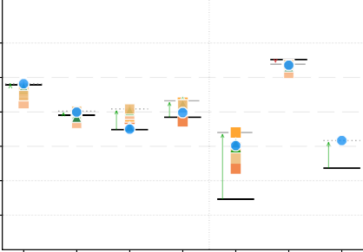
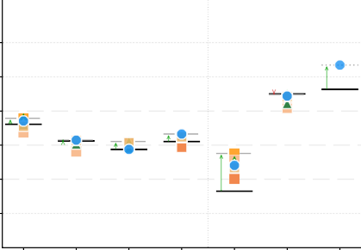
100 100
Dataset Release Date

-3.0%
+0.8%
+16.8%
+4.1% +24.1%
+417.5%
+58.8%
05/25 08/25
05/24 09/24 09/24 12/23
Dataset Release Date
+19.5%
-0.3%
+6.7%
+1.1% +12.3% +10.4%
+169.6%
05/24 09/24 09/24 12/23 05/25 08/25
80 80
Accuracy (%)
60 60
40 40
20 20
0 0
GPT4o
Qwen-14B
Qwen 72B
Llama-70B
MedGemma-27B
GPT 5
GPT4o
Qwen-14B
Qwen 72B
Llama-70B
MedGemma-27B
GPT 5

Figure 3. Effect of Filtering Context on Final Performance. Solid black horizontal lines denote the original baseline accuracy, while dotted lines indicate the highest accuracy achieved. Colored shapes indicate performance when low-relevancy sentences indicated by specific models or humans (GPT-4o, GPT-5, Qwen-14B and Qwen-72B, Llama-70B, MedGemma-27B, Physician Trainee) are removed. Percentage annotations highlight the largest improvement or decline between the baseline and the best observed post-removal accuracy.
Physician + Trainee
Physician + Trainee

Filtering for Human-labeled Relevance Improves LLM Performance (RQ2)
In accordance with RQ2, we next examined the effects of restricting models to using only the sentences that physician trainees had identified as relevant. Removing the sentences that physician

trainees marked as low relevance or irrelevant raised accuracy for most of the LLMs on most datasets (Figure 3). We report these
accuracy improvements after filtering as observed differences rather than as statistically tested effects. The Round 2 subset contained only 248 QA pairs, so we did not attach confidence intervals or significance tests to the per-dataset changes. Qwen-72B’s accuracy rose from 89.3% to 92.2% on MMLU Precision Medicine and from 35.1% to 62.2% overall, while GPT-4o moved from 39.3% to 73.0% overall, keeping its position as the highest performing model before and after filtering. Qwen-14B and Llama-70B had small declines on the MMLU subset (marked in red), which is consistent with sensitivity to small input perturbations in weaker models. Large relative gains for MedGemma-27B were driven by low baseline accuracies and should be interpreted with caution: a change from a low baseline to a still moderate accuracy produces a large percentage change that is not necessarily clinically meaningful. Comparisons with physician trainee unfiltered accuracy (48.3%) are descriptive; the trainees and the models received different inputs in the filtered condition and direct head to head claims about clinical parity are not supported by this simplified QA-based design.
One interpretation of these results could be that focusing on sentences that physician trainees regard as highly relevant reduces the influence of peripheral content in the LLM output. However, alternative interpretations are equally compatible with the data. Shorter inputs (after removing sentences) are easier for LLMs to process; filtering can incidentally remove adversarial distractors that USMLE-style items include in the questions by design; and especially for older datasets such as MMLU Precision Medicine (released 2020) the filtered input may disrupt patterns associated with memorization. Disentangling these mechanisms is beyond the scope of this study. It is also notable that between 1.6% and 18.5% of originally correct predictions flipped to incorrect after removing the sentences that physician trainees labeled as low-relevance or irrelevant (Figure 4). Among the LLMs evaluated, Qwen-14B shows the highest Spurious Rate and GPT-4o the lowest, with the caveat that this metric is not adjusted for the random-sentence removal baseline for each LLM and therefore may reflect general sensitivity to input perturbation.
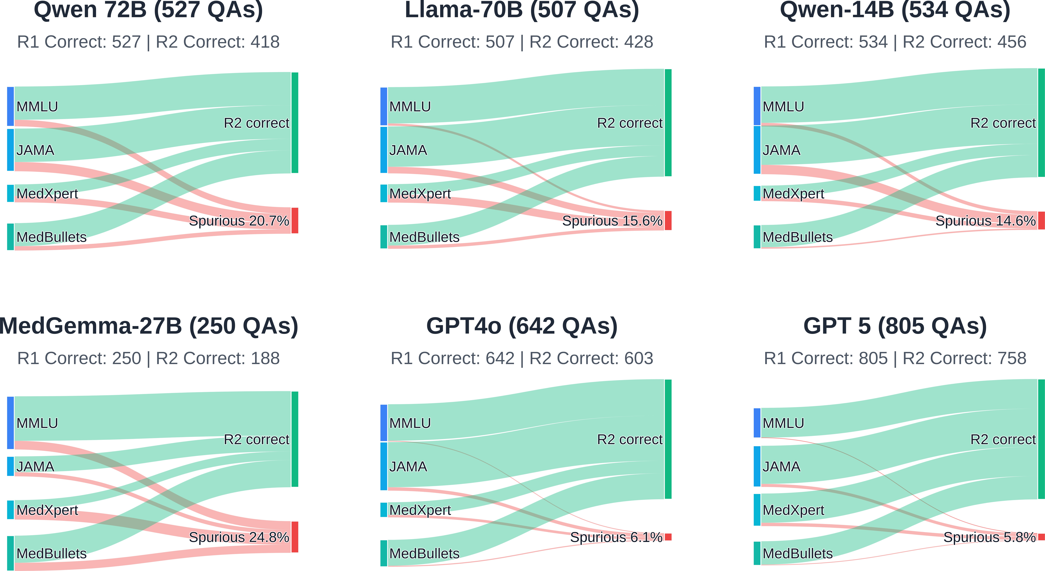

Figure 4. The Spurious Rate (%) of removing physician trainee-identified low-relevance and irrelevant sentences. The green bars indicate QAs that were correct in the first round and remained correct in the second round, while the red bars indicate the proportion of correct QAs that become incorrect in the second round. These QAs showed the opposite trajectory of the intended effect; when low-relevance information was removed the LLM performance for these items deteriorated. For all models, however, the spurious rate was overshadowed by the number of items that changed from incorrect in the first round to correct in the second round.

Filtering for LLM-labeled Relevance Can Improve LLM Performance (RQ3)
Since physician trainee annotations are not practical to obtain for every deployment, we next asked if each LLM could select its own relevant sentences in a two-stage process with a similar directional effect. We evaluated task accuracy when each model was restricted to the sentences that it had labeled highly relevant, using per-sentence ContextCite scores from MedGemma-27B, Llama-70B, Qwen-14B, Qwen-72B, GPT-4o, and GPT-5. The self-filtering conditions are reported alongside the physician trainee filtering conditions in Figure 3.
The most recent flagship LLMs showed limited sensitivity to this self-filtering. GPT-5 exhibited almost no change across the four source datasets, while GPT-4o and the Qwen models showed small accuracy increases. However, weaker and domain-specialized models had larger relative changes (as noted above, large relative changes from low baselines should be read with caution). Similar directional patterns appeared when one model was used to filter another model’s input. We do not claim that self-filtering produces a new, higher performance regime; the more conservative reading is that input restriction based on a model’s own attribution scores is not systematically harmful and can yield small gains on several benchmarks.
At the dataset level, JAMA Clinical Challenge was the most difficult benchmark for all models, with accuracy between 3% and 33%, and with only modest improvements from relevance-based filtering. These observations suggest that part of the gap between weaker and stronger models on MedPAIR is associated with how much each model is distracted by content that is not decisive for the question, although the effect is not large enough to overturn the existing model ordering.

Discussion
Our findings point to a moderate but consistent gap between the relevance judgments of physician trainees and those of current LLMs on clinical QA vignettes, with LLM concordance of 44.9% to 65.9%, compared against a board-certified physician accordance of 72.4% with the trainees. These findings resonate with earlier work showing that LLM performance can be overestimated when benchmark accuracy is read in isolation^{61–63}. We interpret our results as evidence that accuracy metrics alone do not fully describe how LLMs arrive at their answers in this setting, rather than as a sharp dichotomy between aligned humans and misaligned models.
Better alignment between LLM-selected and clinician-selected evidence is a plausible ingredient of clinically deployable AI⁶⁴, but our study does not directly measure clinical deployment outcomes. Our items are multiple choice exam questions, and the sentences labeled as irrelevant in USMLE-style vignettes often serve a pedagogical purpose. Real clinical notes contain redundant, noisy, and sometimes contradictory content drawn from different distributions. Readers should therefore treat our findings as an evaluation study that informs the interpretation of existing medical QA results, and not as direct evidence about behavior in live clinical workflows⁶⁵.
Previous work has shown that selectively pruning input contexts and retaining only the most relevant content can improve QA performance in language models^{66,67}. Our analyses extend these findings to the clinical QA setting by showing that physician trainee annotated context reduction, ContextCite scores from open source models, and self-report prompting of closed source models all produced directional accuracy gains across four medical QA datasets. The MedPAIR dataset makes this kind of analysis possible by pairing sentence level relevance labels from physician trainees with LLM-derived labels on the same items, and we release it so that subsequent studies can revisit reasoning patterns in medical LLMs without recollecting expert annotations.
The empirical findings also speak to whether an LLM can take the place of a human annotator in relevance labeling. While self-reported and ContextCite labels exhibited moderate agreement with physician trainees, the observed gaps and the larger accuracy gains obtained with physician trainee filtering indicate that expert oversight remains valuable in this evaluation setting^{68–71}. The previously established sensitivity of ContextCite and self-reported labels to prompt and scoring choices, especially in healthcare, suggests that LLM generated relevance labels should be used alongside, rather than in place of, human annotations when model outputs carry clinical consequences^{72,73}.
This study has several limitations that future work should address. The human reference in our downstream analyses was a majority vote of physician trainees rather than an independent attending physicians, and the 72.0% trainee–physician matching rate establishes an agreement ceiling that should be kept in mind when interpreting the LLM concordance numbers. We did not separately estimate inter-trainee reliability with standard agreement statistics such as Fleiss’ kappa or Krippendorff’s alpha, and we treated the trainee majority vote as a pragmatic reference. The ternary High / Low / Irrelevant scheme is coarse by design, and our filtering experiments collapse Low Relevance and Irrelevant into a single removed category even though Low Relevance sentences can still support ruling out alternatives, which is a real diagnostic function. The ternary mapping from continuous ContextCite scores holds the per-item number of high relevance sentences fixed to match the trainee majority vote, so concordance measures ranking agreement are conditional on that count rather than an absolute threshold; we discuss alternative mappings in the Supplementary Information.
Our filtering experiments do not disentangle reductions in distraction from several other potentially confounding mechanisms, including shorter input, disruption of patterns associated with training set memorisation on older source datasets such as MMLU Precision Medicine (2020), and incidental removal of adversarial distractors that USMLE-style items include by design. We did not

include a matched random sentence-removal baseline, and without this baseline the Spurious Rate cannot be uniquely attributed to reliance on content that clinicians would consider peripheral^{74–77}. The Round 2 filtering analysis was based on 248 QA pairs and we report observed accuracy differences rather than confidence intervals or significance tests; large relative gains for models with very low baselines, such as MedGemma-27B, should be read in absolute rather than relative terms. The LLMs studied included a mixture of open- and closed-source systems and is not exhaustive—the omission of Med-PaLM, Claude, and other salient models limits the breadth of cross-model comparisons. Finally, the MedPAIR dataset is built from multiple-choice exam QA, and the relevance patterns in exam vignettes may differ systematically from those in real clinical notes^{78,79}. In future work MedPAIR can support studies with matched random and clinician-varied baselines, contamination audits, finer-grained label schemes, and broader LLM coverage.

Methods

Expert Data Annotation
We partnered with Centaur Labs (https://centaur.ai) to employ board-certified physicians and physician trainees (medical students or higher qualifications) to annotate the QA pairs. Physician trainees were chosen for their familiarity with medical exam preparation, as these questions are primarily designed for medical students. Demographic information for the participants is presented in the Supplementary Information.
A total of 52 physician trainees participated (26.9 years mean age), with 77.3% at the advanced training level. Among these participants, 67.4% of the labelers had passed the United States Medical Licensing Examination (USMLE) Step 1 Exam. Notably, half of them reported familiarity with using LLMs in clinical contexts, such as integrating AI tools into clinical queries or workflows. On average, each labeler spent an average of 3.15 minutes (SD 2.90, 95% CI: 3.04–3.25, n = 2952) per QA. Medical students spent on average 3.19 minutes (SD 3.16, 95% CI: 3.21-3.44, n of total annotations = 2018); physicians spent on average 3.05 minutes (SD 2.25, 95% CI: 2.90-3.19, n of total annotations = 934). For each case, the participants first selected the most appropriate answer and then annotated the relevance of every sentence in the patient profile.
A total of 7 physicians participated (43.4 years mean age; 4 reporting as male, 3 reporting as female), with an average of 17.0 years of post-graduate employment. All physicians had passed USMLE Step 3 or equivalent exams. The physician cohort showed high familiarity with the use of LLMs in healthcare, with 5 out of the 7 physicians reporting positive views that LLM deployment is ready for clinician-in-the-loop tasks.
A sample physician trainees’ annotation is presented in Figure 1 (orange boxes). Full study instructions and the pre- and post-survey instruments are provided in the Supplementary Material. Data collection for the annotations occurred between March 6 and May 5, 2025.
Each QA was annotated by at least three physician trainees, and we verified that at least one of the annotators provided the correct answer to the medical question. For each sentence, annotators then applied one of three labels, according to the following instructions: (1) High Relevance: Information that is critical and must be considered to answer the question correctly. These are the key clinical clues or data points that strongly point toward the correct diagnosis or decision. (2) Low Relevance: Information that provides some context or minor clues but is not essential. These details might help rule out alternatives, yet the question could still be answered correctly without them. (3) Irrelevant: Information that is not pertinent to determining the correct answer. These can be distractors or background details included in the vignette that do not impact the outcome in the given context.
This level of detailed expert labeling is largely absent from existing medical QA benchmarks, which typically include only the question and answer, without explicit identification of supporting case details and their degree of relevance⁴⁹.

LLM Data Annotations
We accessed the closed-source models (OpenAI) through their respective Python API libraries from March to October 2025. For the open-source models (Llama, Qwen, and Meditron), we employed the Hugging Face Transformers library. These

models were executed on a local cluster equipped with four NVIDIA A100 GPUs (80 GB each). All models were run with default hyperparameters.
To directly compare the majority-vote annotations of the physician trainees with the labels generated by LLM for each QA, we annotated the LLM outputs using ContextCite for open-source models and using a self-report prompt for all models. ContextCite scores approximate the model’s attention distribution⁸⁰,
providing a simple, scalable mechanism for tracing portions of a generated response back to specific input sentences⁵⁸. Self-reported labels were obtained by prompting the model to generate an assessment of sentence relevance for the QA. For the self-reported outcomes, we proceeded in the same manner as the physician trainee labeling protocol: we fed the identical instruction prompt three times into the LLM and determined the relevance label for each sentence by majority vote. Each model received the identical instruction prompt used by the physician labelers. The complete prompts for generating self-reported labels and ContextCite annotations are provided in the Supplementary Information.

Problem Formulation
Suppose that a particular question consists of a set of sentences S = S ⁺ ∪ S ⁻, where S ⁺ is the set of relevant sentences (as labeled by a physician trainee), and S ⁻ is the set of irrelevant sentences. Let Y ∈ {1, 2, ..., K} be the true label. Suppose we have some LLM f : 2^{S} → {1, 2, ..., K}.
To evaluate if f answers the question using the same information as a human, we compare f (S ) with f (S ⁺), under the assumption that the set f (S ⁺) is sufficient for a human to answer the question correctly. This gives us the following possible scenarios:
- f (S ) = f (S ⁺) = Y : The model is correct in both cases, suggesting that it relies on the same information as a human to solve the problem.
- f (S ) ̸= Y, f (S ⁺) ̸= Y : The model is incorrect in both cases, indicating that the problem is inherently difficult or f has poor capabilities.
- f (S ) = Y, f (S ⁺) ̸= Y : By removing irrelevant sentences, we flip a correct prediction to an incorrect one. This indicates that the model may have been relying on spurious information in S ⁻ (i.e. information for which a human deems irrelevant) to make its predictions.
- f (S ) ̸= Y, f (S ⁺) = Y : The model improves when irrelevant information is removed, indicating that S ⁺ contains sufficient information to answer the question as expected, and the presence of S ⁻ introduces noise or distractions.
As case (3) is the most salient for our purpose, we define the Spurious Rate (Spurious Rate) as the prevalence of samples in this case:
∑^{N} 1[ f (S_{i}) = Y_{i} ∧ f (S ⁺) ̸= Y_{i}]

Spurious Rate( f ) =
,
i=1 i
N

∑i=1 1[ f (S_{i}) = Y_{i}]
where N is the total number of questions.
We treat Spurious Rate as a proxy rather than a direct measure of spurious reasoning. Removing sentences changes the input distribution, and any model may behave differently on a truncated input regardless of whether or not the removed content was informative. The physician trainee labels that define S ⁻ are themselves noisy, so the metric also reflects sensitivity to label noise. A fully controlled interpretation would require a random sentence removal baseline matched for length, which we leave to future work. With these caveats in mind, a higher Spurious Rate indicates that more of a model’s originally correct answers do not survive the removal of sentences that physician trainees judged low relevance or irrelevant, while a lower value indicates more robustness to this particular perturbation.

Data Availability
All data underlying this study’s results are provided in the Supplementary Data. All LLM and physician trainee-labeled data are available at: http://medpair.csail.mit.edu/. The physician trainee-annotated data are available to use through HuggingFace at https://huggingface.co/datasets/YuexingHao/MedPAIR.

Code Availability
All code used in generating this study’s results is presented in the Supplementary Data.

Acknowledgements
This work was supported in part by an award from the Hasso Plattner Foundation, a National Science Foundation (NSF) CAREER Award (#2339381), and an AI2050 Early Career Fellowship (G-25-68042). We also thank Morgan Bouie and Susan Campbell at Centaur Labs for their efforts in coordinating the physician trainees’ data annotations, and Walter Gerych and Olawale Salaudeen for their valuable feedback that strengthened this manuscript.

Author Contributions
Y.H., K.A., H.Z., and M.G. conceived and designed the study. Y.H., K.A., G.Y., and H.J. carried out data collection, processing, and experimental analysis. H.Z., G.Y., I.P., P.T., M.S., S.K., and A.D.S. offered critical intellectual input and guidance. Y.H., H.Z., H.J., and M.G. drafted the initial version of the manuscript. M.G. secured funding and provided overall supervision. All authors contributed to administrative, technical, and material support, reflecting a comprehensive and collaborative team effort.

Competing Interests
The authors declare that they have no competing interests.

References
- de Paula, D. et al. Are we better together? investigating the value of human–ai collaboration for online health communities. In International Conference on Information Systems, ICIS 2025 (2025).
- OpenAI et al. GPT-4 Technical Report, DOI: 10.48550/arXiv.2303.08774 (2024). ArXiv:2303.08774 [cs].
- Singhal, K. et al. Large language models encode clinical knowledge. Nature 620, 172–180 (2023).
- Cabral, S. et al. Clinical Reasoning of a Generative Artificial Intelligence Model Compared With Physicians. JAMA Intern. Medicine 184, 581–583, DOI: 10.1001/jamainternmed.2024.0295 (2024).
- McDuff, D. et al. Towards accurate differential diagnosis with large language models. Nature 1–7, DOI: 10.1038/ s41586-025-08869-4 (2025). Publisher: Nature Publishing Group.
- Liu, X. et al. A generalist medical language model for disease diagnosis assistance. Nat. medicine 31, 932–942 (2025).
- Holmes, J. et al. Radonc-gpt: An autonomous llm agent for real-time patient outcomes labeling at scale. arXiv preprint arXiv:2509.25540 (2025).
- Van Veen, D. et al. Adapted large language models can outperform medical experts in clinical text summarization. Nat. medicine 30, 1134–1142 (2024).
- Li, S. S. et al. MediQ: Question-Asking LLMs and a Benchmark for Reliable Interactive Clinical Reasoning. Adv. Neural Inf. Process. Syst. 37, 28858–28888 (2024).
- Hao, Y. et al. Large language model integrations in cancer decision-making: a systematic review and meta-analysis. npj Digit. Medicine 8, 450 (2025).
- Deng, C., Zhao, Y., Tang, X., Gerstein, M. & Cohan, A. Investigating data contamination in modern benchmarks for large language models. In Duh, K., Gomez, H. & Bethard, S. (eds.) Proceedings of the 2024 Conference of the North American Chapter of the Association for Computational Linguistics: Human Language Technologies (Volume 1: Long Papers), 8706–8719, DOI: 10.18653/v1/2024.naacl-long.482 (Association for Computational Linguistics, Mexico City, Mexico, 2024).
- Xia, P. et al. CARES: A Comprehensive Benchmark of Trustworthiness in Medical Vision Language Models. Adv. Neural Inf. Process. Syst. 37, 140334–140365 (2024).
- Park, W. B., Kang, S. H., Lee, Y.-S. & Myung, S. J. Does Objective Structured Clinical Examinations Score Reflect the Clinical Reasoning Ability of Medical Students? The Am. J. Med. Sci. 350, 64–67, DOI: 10.1097/MAJ.0000000000000420 (2015).
- Konopasky, A. et al. Understanding context specificity: the effect of contextual factors on clinical reasoning. Diagnosis 7, 257–264, DOI: doi:10.1515/dx-2020-0016 (2020).
- Sayres, R. et al. Towards better health conversations: The benefits of context-seeking. arXiv preprint arXiv:2510.18880
(2025).

- Hao, Y. Outcome first or overview first? optimizing patient-oriented framework for evidence-based healthcare treatment selections with xai tools. In Companion Publication of the 2024 Conference on Computer-Supported Cooperative Work and Social Computing, 248–254 (2024).
- Farquhar, S., Kossen, J., Kuhn, L. & Gal, Y. Detecting hallucinations in large language models using semantic entropy.
Nature 630, 625–630, DOI: 10.1038/s41586-024-07421-0 (2024). Publisher: Nature Publishing Group.
- Choe, S. K. et al. What is Your Data Worth to GPT? LLM-Scale Data Valuation with Influence Functions, DOI: 10.48550/arXiv.2405.13954 (2024). ArXiv:2405.13954 [cs].
- Cohen-Wang, B., Chuang, Y.-S. & Madry, A. Learning to Attribute with Attention, DOI: 10.48550/arXiv.2504.13752 (2025). ArXiv:2504.13752 [cs].
- Liu, F., Kandpal, N. & Raffel, C. Attribot: A bag of tricks for efficiently approximating leave-one-out context attribution. In The Thirteenth International Conference on Learning Representations.
- DeYoung, J. et al. ERASER: A Benchmark to Evaluate Rationalized NLP Models. In Jurafsky, D., Chai, J., Schluter, N. & Tetreault, J. (eds.) Proceedings of the 58th Annual Meeting of the Association for Computational Linguistics, 4443–4458, DOI: 10.18653/v1/2020.acl-main.408 (Association for Computational Linguistics, Online, 2020).
- Es, S., James, J., Espinosa Anke, L. & Schockaert, S. RAGAs: Automated Evaluation of Retrieval Augmented Generation. In Aletras, N. & De Clercq, O. (eds.) Proceedings of the 18th Conference of the European Chapter of the Association for Computational Linguistics: System Demonstrations, 150–158 (Association for Computational Linguistics, St. Julians, Malta, 2024).
- Zhao, W. et al. MoverScore: Text Generation Evaluating with Contextualized Embeddings and Earth Mover Distance. In Inui, K., Jiang, J., Ng, V. & Wan, X. (eds.) Proceedings of the 2019 Conference on Empirical Methods in Natural Language Processing and the 9th International Joint Conference on Natural Language Processing (EMNLP-IJCNLP), 563–578, DOI: 10.18653/v1/D19-1053 (Association for Computational Linguistics, Hong Kong, China, 2019).
- Schuler, K. et al. Context factors in clinical decision-making: a scoping review. BMC Med. Informatics Decis. Mak. 25, 133, DOI: 10.1186/s12911-025-02965-1 (2025).
- Adam, H., Balagopalan, A., Alsentzer, E., Christia, F. & Ghassemi, M. Mitigating the impact of biased artificial intelligence in emergency decision-making. Commun. Medicine 2, 149 (2022).
- Khattab, O., Potts, C. & Zaharia, M. Baleen: robust multi-hop reasoning at scale via condensed retrieval. In Proceedings of the 35th International Conference on Neural Information Processing Systems, NIPS ’21, 27670–27682 (Curran Associates Inc., Red Hook, NY, USA, 2021).
- Chuang, Y.-S. et al. SelfCite: Self-Supervised Alignment for Context Attribution in Large Language Models, DOI: 10.48550/arXiv.2502.09604 (2025). ArXiv:2502.09604 [cs].
- Lu, P. et al. Learn to Explain: Multimodal Reasoning via Thought Chains for Science Question Answering (2022).
- Buçinca, Z., Malaya, M. B. & Gajos, K. Z. To Trust or to Think: Cognitive Forcing Functions Can Reduce Overreliance on AI in AI-assisted Decision-making. Proc. ACM Hum.-Comput. Interact. 5, 188:1–188:21, DOI: 10.1145/3449287 (2021).
- Gourabathina, A., Gerych, W., Pan, E. & Ghassemi, M. The medium is the message: How non-clinical information shapes clinical decisions in llms. In Proceedings of the 2025 ACM Conference on Fairness, Accountability, and Transparency, 1805–1828 (2025).
- Strong, E. et al. Chatbot vs Medical Student Performance on Free-Response Clinical Reasoning Examinations. JAMA internal medicine 183, 1028–1030, DOI: 10.1001/jamainternmed.2023.2909 (2023).
- Katz, U. et al. GPT versus Resident Physicians — A Benchmark Based on Official Board Scores. NEJM AI 1, AIdbp2300192, DOI: 10.1056/AIdbp2300192 (2024). Publisher: Massachusetts Medical Society.
- Chiang, C.-H. & Lee, H.-y. Can Large Language Models Be an Alternative to Human Evaluations? In Rogers, A., Boyd-Graber, J. & Okazaki, N. (eds.) Proceedings of the 61st Annual Meeting of the Association for Computational Linguistics (Volume 1: Long Papers), 15607–15631, DOI: 10.18653/v1/2023.acl-long.870 (Association for Computational Linguistics, Toronto, Canada, 2023).
- McCoy, L. G. et al. Assessment of large language models in clinical reasoning: A novel benchmarking study. NEJM AI 2, AIdbp2500120, DOI: 10.1056/AIdbp2500120 (2025). https://ai.nejm.org/doi/pdf/10.1056/AIdbp2500120.
- Huang, Y. et al. On the trustworthiness of generative foundation models: Guideline, assessment, and perspective. arXiv preprint arXiv:2502.14296 (2025).

- Huang, Y. et al. Probellm: Automating principled diagnosis of llm failures. arXiv preprint arXiv:2602.12966 (2026).
- Zhou, S. et al. Explainable differential diagnosis with dual-inference large language models. npj Heal. Syst. 2, 1–9, DOI: 10.1038/s44401-025-00015-6 (2025). Publisher: Nature Publishing Group.
- Wu, J. et al. MedReason: Eliciting Factual Medical Reasoning Steps in LLMs via Knowledge Graphs, DOI: 10.48550/ arXiv.2504.00993 (2025). ArXiv:2504.00993 [cs].
- Bansal, G. et al. Does the Whole Exceed its Parts? The Effect of AI Explanations on Complementary Team Performance. In Proceedings of the 2021 CHI Conference on Human Factors in Computing Systems, CHI ’21, 1–16, DOI: 10.1145/ 3411764.3445717 (Association for Computing Machinery, New York, NY, USA, 2021).
- Pal, A., Umapathi, L. K. & Sankarasubbu, M. MedMCQA: A Large-scale Multi-Subject Multi-Choice Dataset for Medical domain Question Answering. In Proceedings of the Conference on Health, Inference, and Learning, 248–260 (PMLR, 2022). ISSN: 2640-3498.
- Zhang, D. et al. A survey of datasets in medicine for large language models. Intell. & Robotics 4, 457–478, DOI: 10.20517/ir.2024.27 (2024). Publisher: OAE Publishing Inc.
- Jin, C. et al. RJUA-MedDQA: A Multimodal Benchmark for Medical Document Question Answering and Clinical Reasoning. In Proceedings of the 30th ACM SIGKDD Conference on Knowledge Discovery and Data Mining, KDD ’24, 5218–5229, DOI: 10.1145/3637528.3671644 (Association for Computing Machinery, New York, NY, USA, 2024).
- Soni, S., Gudala, M., Pajouhi, A. & Roberts, K. RadQA: A Question Answering Dataset to Improve Comprehension of Radiology Reports. In Calzolari, N. et al. (eds.) Proceedings of the Thirteenth Language Resources and Evaluation Conference, 6250–6259 (European Language Resources Association, Marseille, France, 2022).
- Toma, A. et al. Clinical Camel: An Open Expert-Level Medical Language Model with Dialogue-Based Knowledge Encoding, DOI: 10.48550/arXiv.2305.12031 (2023). ArXiv:2305.12031 [cs].
- Adlakha, V., BehnamGhader, P., Lu, X. H., Meade, N. & Reddy, S. Evaluating Correctness and Faithfulness of Instruction-Following Models for Question Answering. Transactions Assoc. for Comput. Linguist. 12, 681–699, DOI: 10.1162/tacl_a_ 00667 (2024). Place: Cambridge, MA Publisher: MIT Press.
- Bedi, S., Cui, H., Fuentes, M. et al. Holistic evaluation of large language models for medical tasks with medhelm. Nat. Medicine DOI: 10.1038/s41591-025-04151-2 (2026).
- Khandekar, N. et al. Medcalc-bench: Evaluating large language models for medical calculations. Adv. Neural Inf. Process. Syst. 37, 84730–84745 (2024).
- Hendrycks, D. et al. Measuring Massive Multitask Language Understanding, DOI: 10.48550/arXiv.2009.03300 (2021). ArXiv:2009.03300 [cs].
- Chen, H., Fang, Z., Singla, Y. & Dredze, M. Benchmarking Large Language Models on Answering and Explaining Challenging Medical Questions. In Chiruzzo, L., Ritter, A. & Wang, L. (eds.) Proceedings of the 2025 Conference of the Nations of the Americas Chapter of the Association for Computational Linguistics: Human Language Technologies (Volume 1: Long Papers), 3563–3599 (Association for Computational Linguistics, Albuquerque, New Mexico, 2025).
- Zuo, Y. et al. MedXpertQA: Benchmarking Expert-Level Medical Reasoning and Understanding, DOI: 10.48550/arXiv. 2501.18362 (2025). ArXiv:2501.18362 [cs].
- Hurst, A. et al. Gpt-4o system card. arXiv preprint arXiv:2410.21276 (2024).
- Singh, A. et al. Openai gpt-5 system card. arXiv preprint arXiv:2601.03267 (2025).
- Sellergren, A. et al. Medgemma technical report. arXiv preprint arXiv:2507.05201 (2025).
- Qwen et al. Qwen2.5 Technical Report, DOI: 10.48550/arXiv.2412.15115 (2025). ArXiv:2412.15115 [cs].
- Grattafiori, A. et al. The Llama 3 Herd of Models, DOI: 10.48550/arXiv.2407.21783 (2024). ArXiv:2407.21783 [cs].
- Choi, J. Identifying Key Terms in Prompts for Relevance Evaluation with GPT Models, DOI: 10.48550/arXiv.2405.06931 (2024). ArXiv:2405.06931 [cs].
- Wang, X. et al. MedCite: Can language models generate verifiable text for medicine? In Che, W., Nabende, J., Shutova,
E. & Pilehvar, M. T. (eds.) Findings of the Association for Computational Linguistics: ACL 2025, 18891–18913, DOI: 10.18653/v1/2025.findings-acl.967 (Association for Computational Linguistics, Vienna, Austria, 2025).
- Cohen-Wang, B., Shah, H., Georgiev, K. & Madry, A. ContextCite: Attributing Model Generation to Context (2024).

- Cutler, D., Skinner, J. S., Stern, A. D. & Wennberg, D. Physician Beliefs and Patient Preferences: A New Look at Regional Variation in Health Care Spending. Am. Econ. Journal: Econ. Policy 11, 192–221, DOI: 10.1257/pol.20150421 (2019).
- Hao, Y. et al. Measuring physicians and ai relevance alignment in medical question answering, DOI: 10.17605/OSF.IO/ T72J5 (2025).
- Bao, G., Zhang, H., Yang, L., Wang, C. & Zhang, Y. LLMs with Chain-of-Thought Are Non-Causal Reasoners. CoRR
(2024).
- Ishii, A., Inoue, N., Suzuki, H. & Sekine, S. Analysis of LLM‘s “Spurious” Correct Answers Using Evidence Information of Multi-hop QA Datasets. In Biswas, R. et al. (eds.) Proceedings of the 1st Workshop on Knowledge Graphs and Large Language Models (KaLLM 2024), 24–34, DOI: 10.18653/v1/2024.kallm-1.3 (Association for Computational Linguistics, Bangkok, Thailand, 2024).
- de Hond, A. et al. From text to treatment: the crucial role of validation for generative large language models in health care.
The Lancet Digit. Heal. 6, e441–e443 (2024).
- Gourabathina, A., Hao, Y., Gerych, W. & Ghassemi, M. The medperturb dataset: What non-content perturbations reveal about human and clinical llm decision making. arXiv preprint arXiv:2506.17163 (2025).
- Yang, Q. et al. Harnessing Biomedical Literature to Calibrate Clinicians’ Trust in AI Decision Support Systems. In Proceedings of the 2023 CHI Conference on Human Factors in Computing Systems, CHI ’23, 1–14, DOI: 10.1145/3544548. 3581393 (Association for Computing Machinery, New York, NY, USA, 2023).
- McKechnie, J., McDonald, G. & Macdonald, C. Context Example Selection for LLM Generated Relevance Assessments. In Advances in Information Retrieval: 47th European Conference on Information Retrieval, ECIR 2025, Lucca, Italy, April 6–10, 2025, Proceedings, Part I, 293–309, DOI: 10.1007/978-3-031-88708-6_19 (Springer-Verlag, Berlin, Heidelberg, 2025).
- Kabongo, S., D’Souza, J. & Auer, S. Effective Context Selection in LLM-Based Leaderboard Generation: An Empirical Study. In Rapp, A., Di Caro, L., Meziane, F. & Sugumaran, V. (eds.) Natural Language Processing and Information Systems, 150–160, DOI: 10.1007/978-3-031-70242-6_15 (Springer Nature Switzerland, Cham, 2024).
- Shi, L. et al. Judging the Judges: A Systematic Study of Position Bias in LLM-as-a-Judge, DOI: 10.48550/arXiv.2406.07791 (2025). ArXiv:2406.07791 [cs].
- Zheng, L. et al. Judging LLM-as-a-Judge with MT-Bench and Chatbot Arena. Adv. Neural Inf. Process. Syst. 36, 46595–46623 (2023).
- Soboroff, I. Don’t Use LLMs to Make Relevance Judgments. Inf. Retr. Res. 1, 29–46, DOI: 10.54195/irrj.19625 (2025). Number: 1.
- Qiu, P. et al. Quantifying the reasoning abilities of llms on clinical cases. Nat. Commun. 16, 9799 (2025).
- Li, X. et al. Medguide: Benchmarking clinical decision-making in large language models. arXiv preprint arXiv:2505.11613
(2025).
- Abbasiantaeb, Z., Meng, C., Azzopardi, L. & Aliannejadi, M. Can We Use Large Language Models to Fill Relevance Judgment Holes?, DOI: 10.48550/arXiv.2405.05600 (2024). ArXiv:2405.05600 [cs].
- Gu, J. et al. A Survey on LLM-as-a-Judge, DOI: 10.48550/arXiv.2411.15594 (2025). ArXiv:2411.15594 [cs].
- Panickssery, A., Bowman, S. R. & Feng, S. LLM Evaluators Recognize and Favor Their Own Generations (2024).
- Radevski, G. et al. On synthesizing data for context attribution in question answering. arXiv preprint arXiv:2504.05317
(2025).
- Zuccon, G., Koopman, B. & Shaik, R. Chatgpt hallucinates when attributing answers. In Proceedings of the Annual International ACM SIGIR Conference on Research and Development in Information Retrieval in the Asia Pacific Region, 46–51 (2023).
- Croxford, E. et al. Current and future state of evaluation of large language models for medical summarization tasks. npj Heal. Syst. 2, 1–13, DOI: 10.1038/s44401-024-00011-2 (2025). Publisher: Nature Publishing Group.
- Sharma, S., Asri, L. E., Schulz, H. & Zumer, J. Relevance of Unsupervised Metrics in Task-Oriented Dialogue for Evaluating Natural Language Generation, DOI: 10.48550/arXiv.1706.09799 (2017). ArXiv:1706.09799 [cs].
- Bohnet, B. et al. Attributed Question Answering: Evaluation and Modeling for Attributed Large Language Models, DOI: 10.48550/arXiv.2212.08037 (2023). ArXiv:2212.08037 [cs].
- OpenAI et al. GPT-4o System Card, DOI: 10.48550/arXiv.2410.21276 (2024). ArXiv:2410.21276 [cs].

